Ideation Phase
Brainstorm & Idea Prioritization Template

Date | 6 July 2026
Team ID | 6a3b7ad24a7e4ac84601e5d5
Project Name | Automated Employee Onboarding & Off boarding System
Maximum Marks | 4 Marks

Brainstorm & Idea Prioritization Template:
Brainstorming provides a free and open environment that encourages everyone within a team to participate in the creative thinking process that leads to problem solving. Prioritizing volume over value, out-of-the-box ideas are welcome and built upon, and all participants are encouraged to collaborate, helping each other develop a rich amount of creative solutions.
Step-1:Team Gathering, Collaboration and Select the Problem Statement

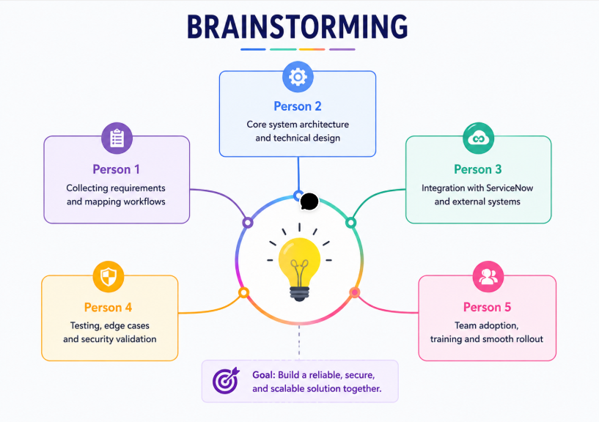

Step 2: Brainstorming, Idea Listing and Grouping
S.No | Idea Description | Category
1 | Automate employee onboarding request process | Workflow Automation
2 | Automate employee offboarding process | Workflow Automation
3 | Create Service Catalog items for onboarding and offboarding | Service Catalog
4 | Generate automatic tasks for HR, IT, Facilities and Security | Task Automation
5 | Configure approval workflows using Flow Designer | Approval Management
6 | Implement role-based ACLs for secure access | Security
7 | Configure SLA monitoring for task completion | SLA Management
8 | Send automatic email notifications | Notification System
9 | Design HR dashboards and reports | Dashboard & Reporting
10 | Track employee lifecycle status in real time | Employee Tracking
11 | Test complete onboarding/offboarding workflow | Testing
12 | Improve compliance using audit trails | Compliance

